**Exercise: Client – Server, Electrocardiography (ECG)**

In this exercise, you will continue with the ECG exercise. Last time you used the producer-consumer pattern to decouple the collection of samples from the processing of samples and allow collection and processing to run in separate threads.

This time you will make the producer and consumer run as separate programs and have the producer send data to the consumer using a TCP connection on an IP network.

The design you ended up with last time should look somewhat like this:

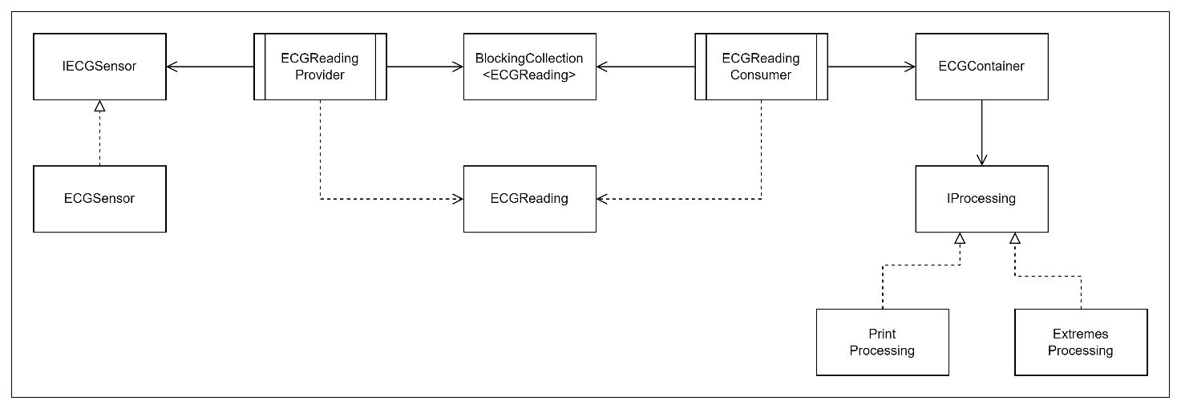

A design where the producer and consumer are two separate programs will look like this:

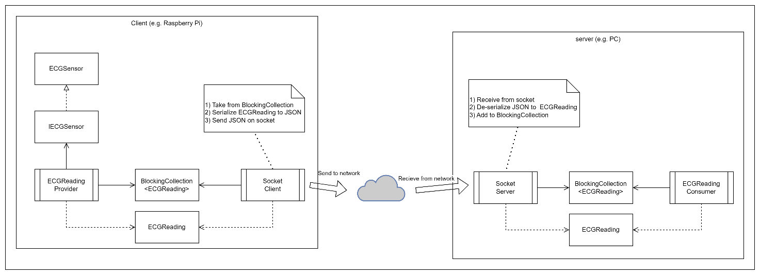

**Exercise 1:**

Change your program from last time to fit the new design.

For a start, run both the client and the server on the same machine. Use the loopback address 127.0.0.1 and a port of your own choice.